DDOS ATTACK DETECTION AND MITIGATION (REAL-TIME DDOS DETECTION AND ADAPTIVE MITIGATION FRAMEWORK USING MACHINE LEARNING)
Block Diagrams (all)
Department of Computer Science and Engineering, [COLLEGE NAME]
Batch C15 (CSE-C) · Academic year [ACADEMIC YEAR]
Table 1: Project team
S.No. | Student name | Roll number
1 | Mallela Pallavi | 23K91A05E3
2 | Kattoju Durgabhavani | 24K95A0514
3 | Nimmala Rakshitha | 23K91A05H3
4 | Prodhatoor Shashi Preetham | 23K91A05K0

Project guide: V Meenakshi
Chapter and section numbers quoted in the text (for example Chapter 8 or Section 6.2) refer to the full project report, 17.Final Document. Figures and tables in this document are numbered from 1.

1. INDEX OF DIAGRAMS
Every diagram was generated from the real design by scripts/docs/make_diagrams.py (matplotlib, 150 dpi) and mirrors the code in app.py, monitoring/, ml/, security/, database/db.py and frontend/src/. The database has no declared foreign keys, so the entity-relationship diagram shows the four tables and one logical link.
Table 2: Diagrams in this document
No. | Diagram | Image file
1 | System architecture | docs/diagrams/01_system_architecture.png
2 | High-level workflow | docs/diagrams/02_high_level_workflow.png
3 | Data flow diagram, level 0 | docs/diagrams/03_dfd_level0.png
4 | Data flow diagram, level 1 | docs/diagrams/04_dfd_level1.png
5 | Data flow diagram, level 2 | docs/diagrams/05_dfd_level2.png
6 | UML class diagram | docs/diagrams/06_uml_class.png
7 | Sequence diagram of the main flow | docs/diagrams/07_sequence_main_flow.png
8 | Use-case diagram | docs/diagrams/08_use_case.png
9 | Entity-relationship diagram | docs/diagrams/09_er_diagram.png
10 | Flowchart of the core algorithm | docs/diagrams/10_flowchart_core_algorithm.png

2. DIAGRAMS

System architecture
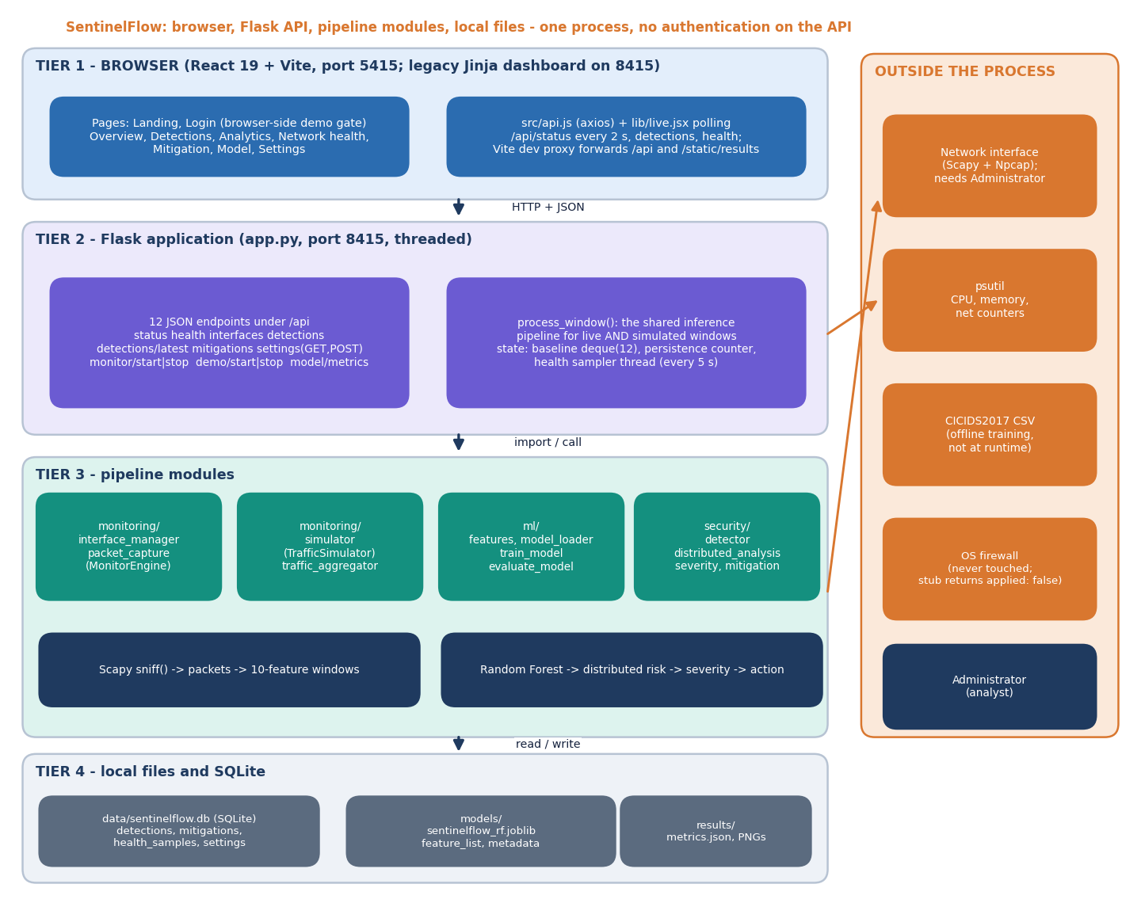
Figure 1: System architecture of SentinelFlow: browser tier, Flask API, pipeline modules and local files.
SentinelFlow is a single Python process with a browser front end. The React console (port 5415 in development) talks to the Flask application (port 8415) over JSON; the original server-rendered dashboard is still served by the same Flask process at /. Flask owns the shared inference function process_window(), a rolling baseline of twelve packet rates, a persistence counter and a background thread that samples CPU, memory and network counters every five seconds. The pipeline modules sit underneath: monitoring/ captures or simulates packets and aggregates them into the ten-feature schema, ml/ holds the schema, the training script and the model loader, and security/ holds the detector, the distributed-risk rule layer, the severity engine and the mitigation manager. State is kept in SQLite and in joblib/JSON/PNG files. Outside the process are the network interface (reached through Scapy and Npcap), psutil, the CICIDS2017 files used only at training time, and the operating-system firewall, which SentinelFlow never changes.

High-level workflow
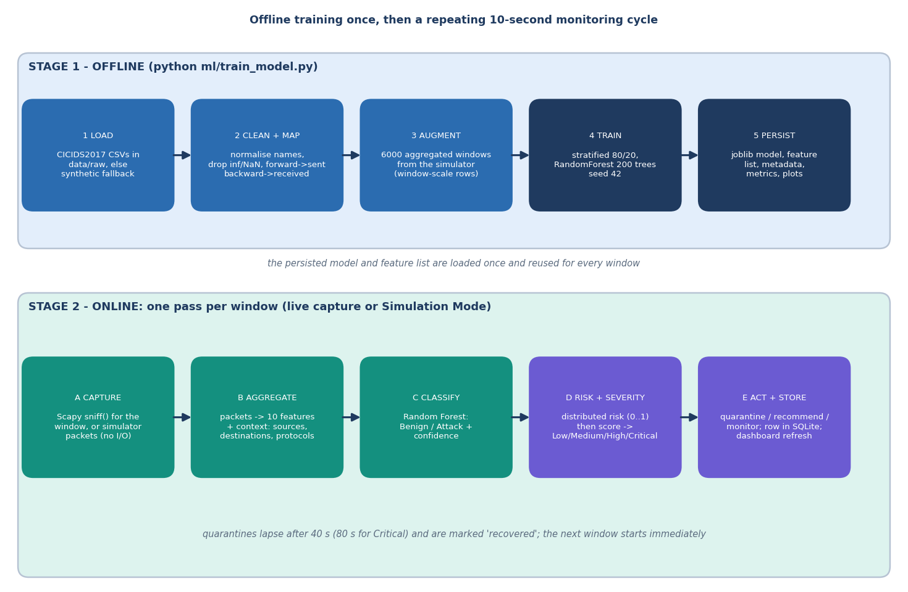
Figure 2: High-level workflow: offline training once, then a repeating capture, aggregate, classify, assess and act cycle.
The workflow has two stages. Offline, ml/train_model.py loads CICIDS2017 CSV files from data/raw (or builds a labelled synthetic fallback when none is present), cleans and maps them to the common schema, adds 6,000 aggregated simulator windows so that window-scale feature values are represented, trains a 200-tree Random Forest on a stratified 80/20 split and persists the model, feature list, metadata, metrics and plots. Online, every monitoring window (ten seconds by default) goes through five steps: packets are captured by Scapy or generated by the simulator, aggregated into ten features plus context, classified by the forest, scored for distributed risk and severity, and finally turned into an action (quarantine, recommendation or monitoring) that is stored in SQLite and shown on the console. Quarantines expire by themselves after 40 seconds (80 for Critical).

Data flow diagram, level 0
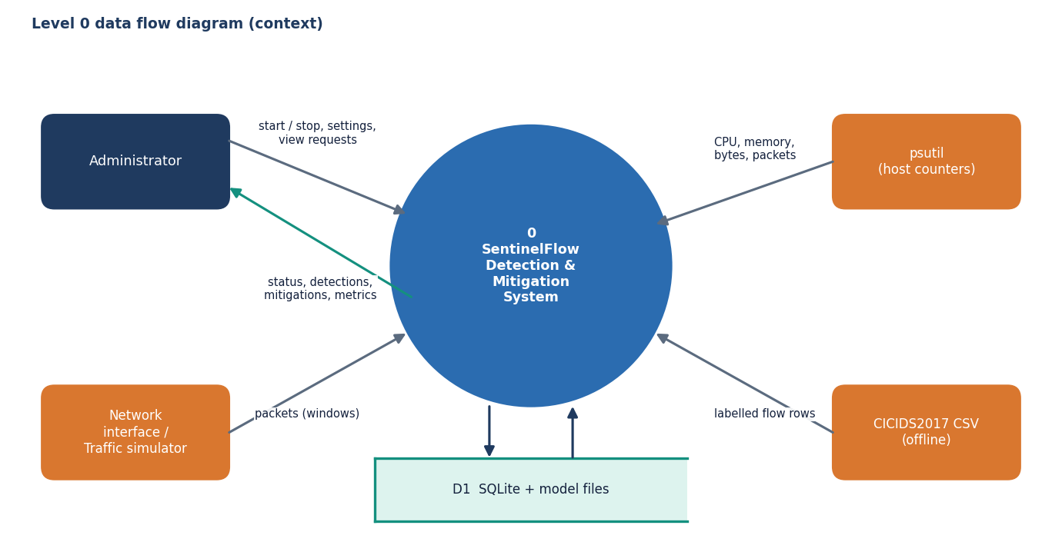
Figure 3: Level 0 data flow diagram: SentinelFlow and its four external entities.
The context diagram treats SentinelFlow as one process. The administrator sends start, stop, settings and view requests and receives status, detections, mitigations and model metrics. The network interface (or the traffic simulator) supplies packets; psutil supplies host counters; the CICIDS2017 CSV supplies labelled flow rows at training time only. One data store, D1, stands for the SQLite database and the model files that the process reads and writes.

Data flow diagram, level 1
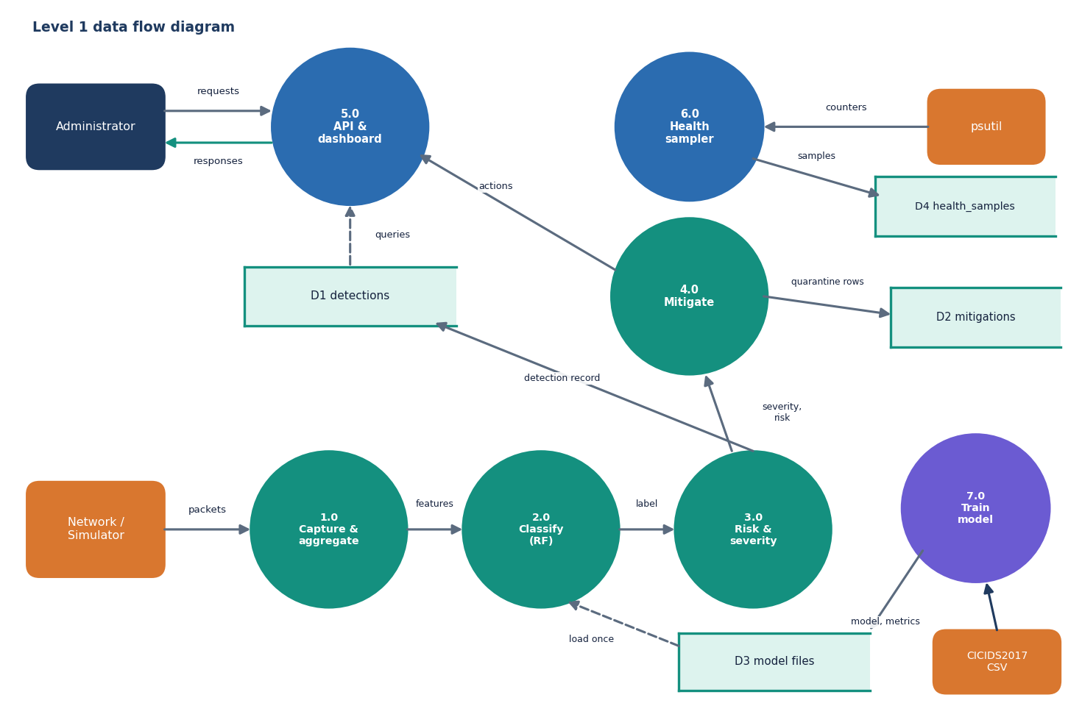
Figure 4: Level 1 data flow diagram: seven processes and four data stores.
Level 1 splits the system into seven processes. 1.0 captures and aggregates packets, 2.0 classifies the feature vector with the Random Forest, 3.0 computes distributed risk and severity, and 4.0 chooses and applies a mitigation; these four run once per window. 5.0 is the Flask API and dashboard that answer the administrator's requests from D1 (detections), 6.0 is the health sampler that writes psutil counters to D4, and 7.0 is the offline training process that turns CICIDS2017 rows into the model files in D3 which process 2.0 loads once. Quarantine rows go to D2.

Data flow diagram, level 2
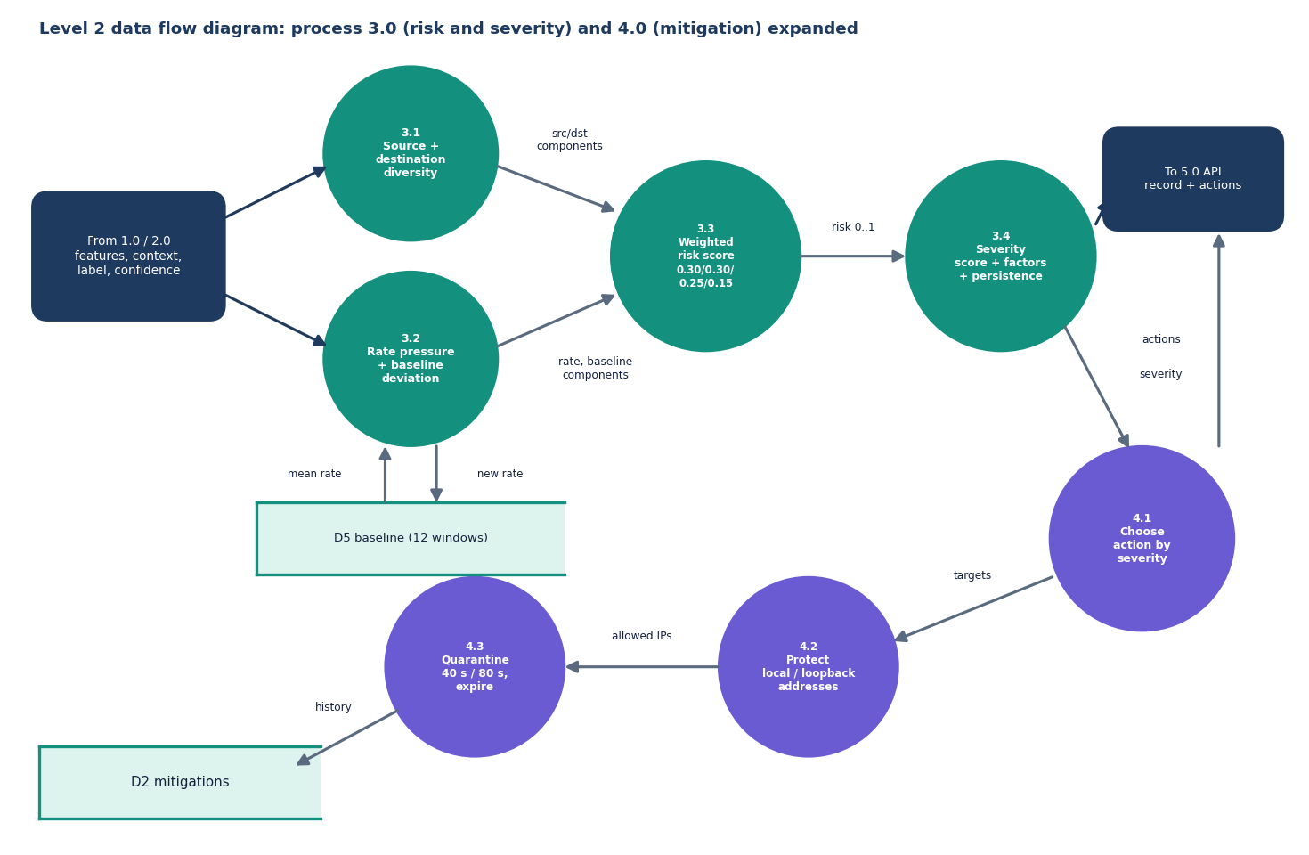
Figure 5: Level 2 data flow diagram: processes 3.0 (risk and severity) and 4.0 (mitigation) expanded.
Process 3.0 is expanded into four sub-processes. 3.1 and 3.2 compute the four components of the distributed-risk score (source diversity, destination diversity, packet-rate pressure and deviation from the rolling baseline, which is read from and appended to the twelve-window baseline store D5); 3.3 combines them with the weights 0.30, 0.30, 0.25 and 0.15; 3.4 adds the model label, its confidence, rate, spread and persistence into a severity score and a list of contributing factors. Process 4.0 then chooses an action from the severity (4.1), removes protected local and loopback addresses from the target list (4.2) and quarantines the remaining top sources for a limited time, writing each action to D2 and expiring it later (4.3).

UML class diagram
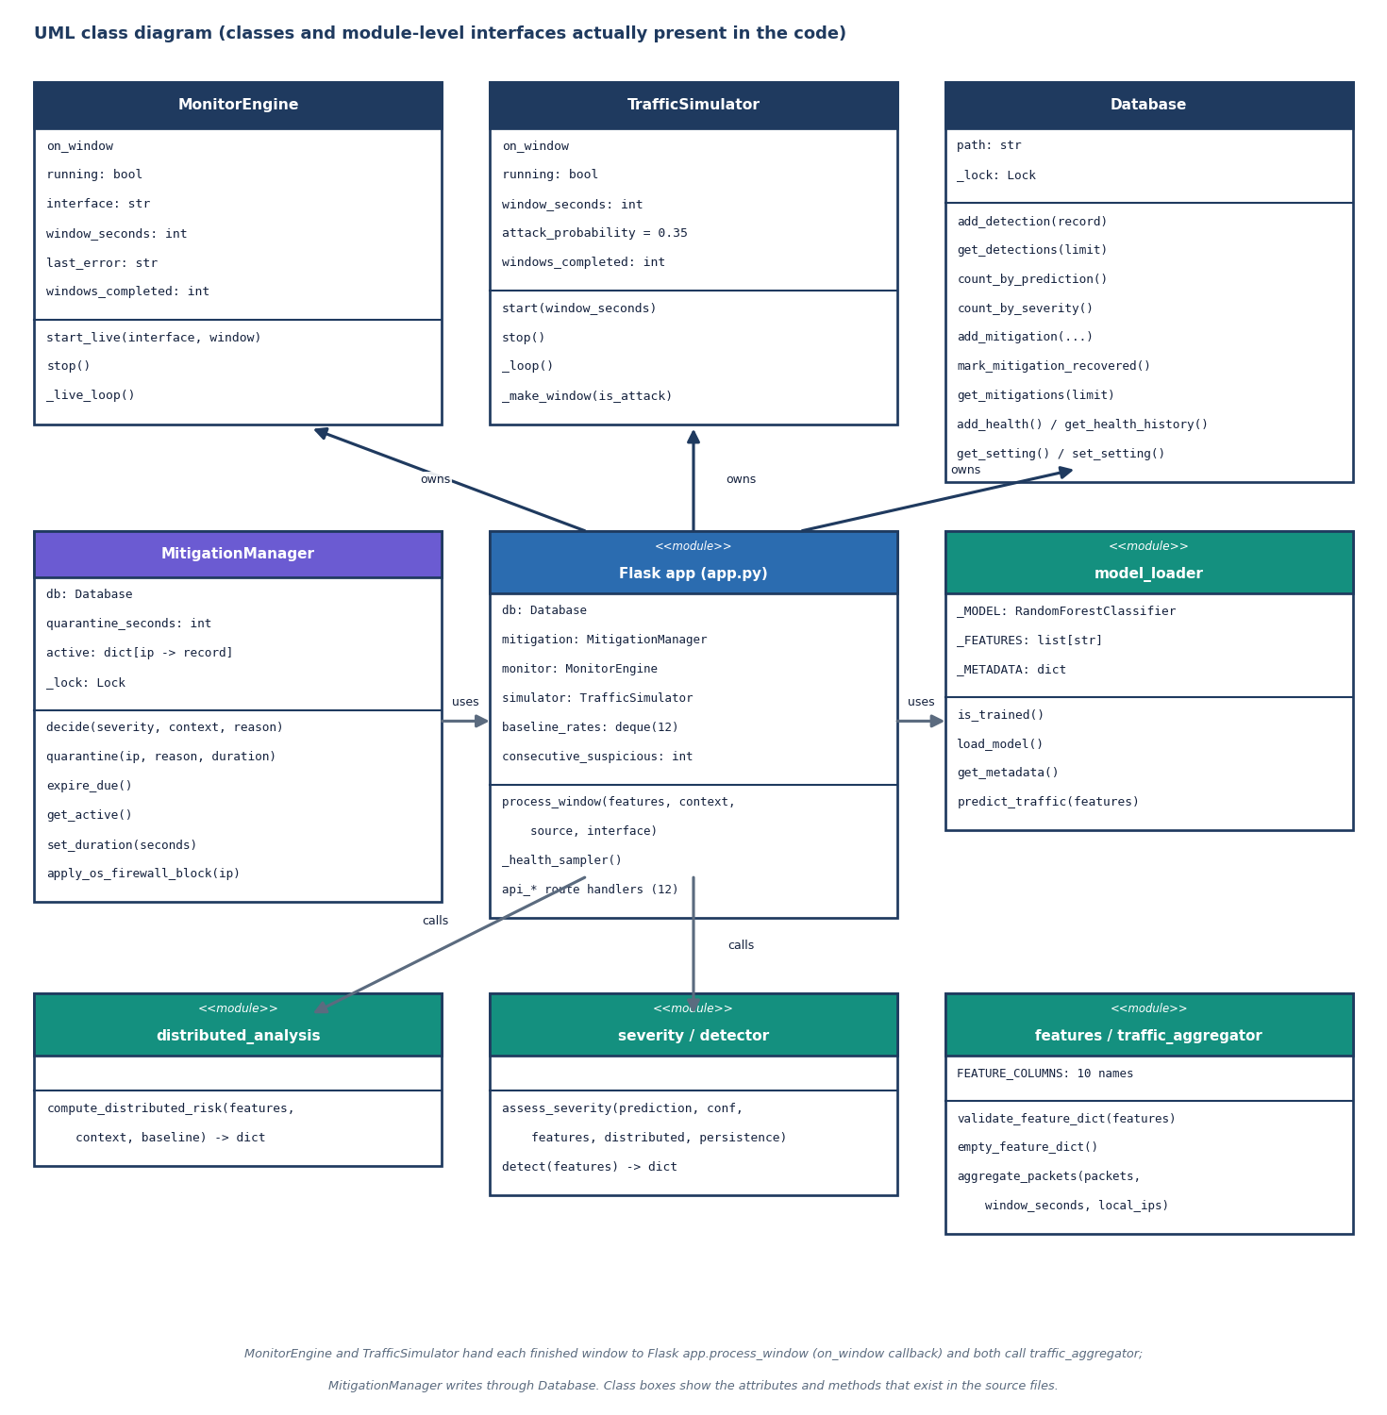
Figure 6: UML class diagram of the classes and module-level interfaces present in the code.
The code has four real classes and several function modules. MonitorEngine and TrafficSimulator produce windows and hand each one to a callback; Database wraps SQLite behind a lock; MitigationManager keeps the active quarantines in memory, writes history through Database and expires entries on every call. The Flask module owns one instance of each and contains process_window(). model_loader, distributed_analysis, severity, detector, features and traffic_aggregator are plain modules of functions; they are drawn as classes with the stereotype <<module>> so that their interfaces can be read at a glance.

Sequence diagram of the main flow
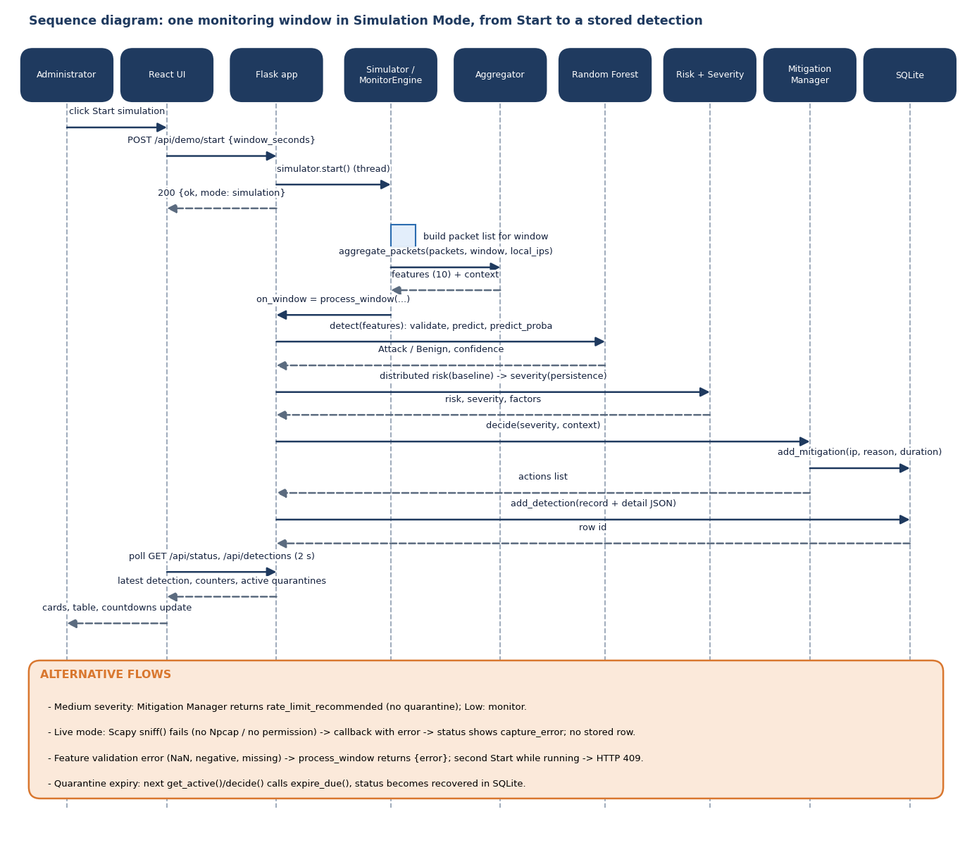
Figure 7: Sequence diagram: one monitoring window in Simulation Mode, from pressing Start to a stored detection.
The main flow starts when the administrator presses Start simulation. The React page posts to /api/demo/start; Flask starts the simulator thread and answers at once. For each window the simulator builds a packet list, calls the aggregator, and passes the ten features and context to process_window(). Flask asks the Random Forest for a label and confidence, computes distributed risk and severity, asks the mitigation manager for actions (which writes quarantine rows) and stores the detection with its full detail as JSON. The console polls /api/status and /api/detections every two seconds and redraws. The alternative flows at the bottom cover Medium and Low severity, a failing live capture, validation errors, a second Start and quarantine expiry.

Use-case diagram
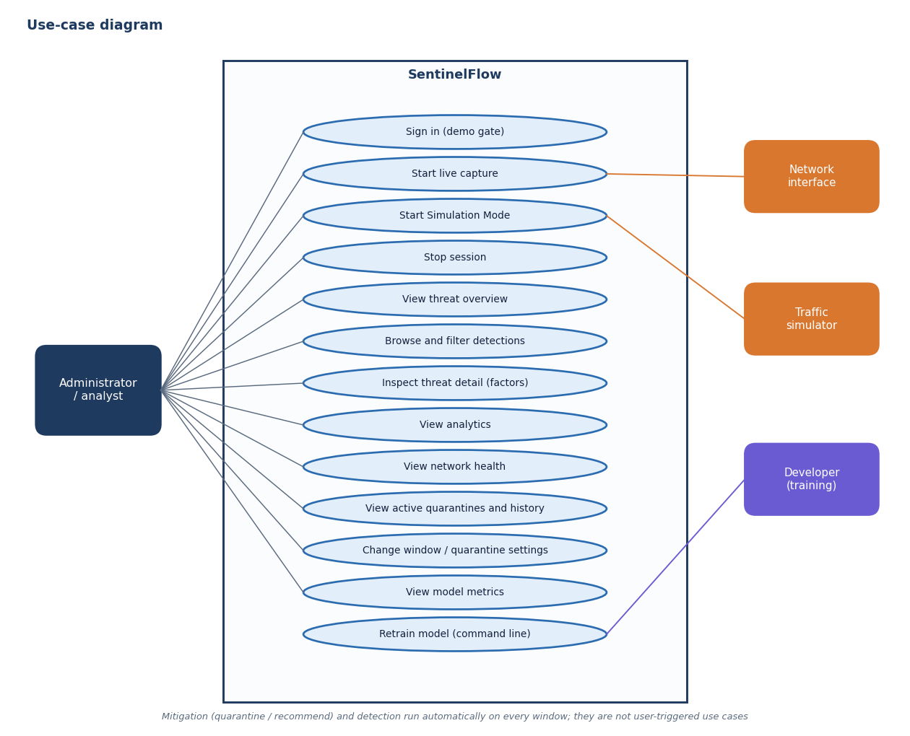
Figure 8: Use-case diagram: what the administrator and the external actors can do.
The only human actor is the administrator (analyst). The use cases are signing in through the demo gate, starting live capture or Simulation Mode, stopping a session, viewing the threat overview, browsing and filtering detections, inspecting the contributing factors of one detection, viewing analytics, network health, quarantines and model metrics, and changing the monitoring window or quarantine length. The network interface and the traffic simulator are the two sources of windows; a developer retrains the model from the command line. Detection and mitigation are deliberately not user use cases: they run on every window.

Entity-relationship diagram
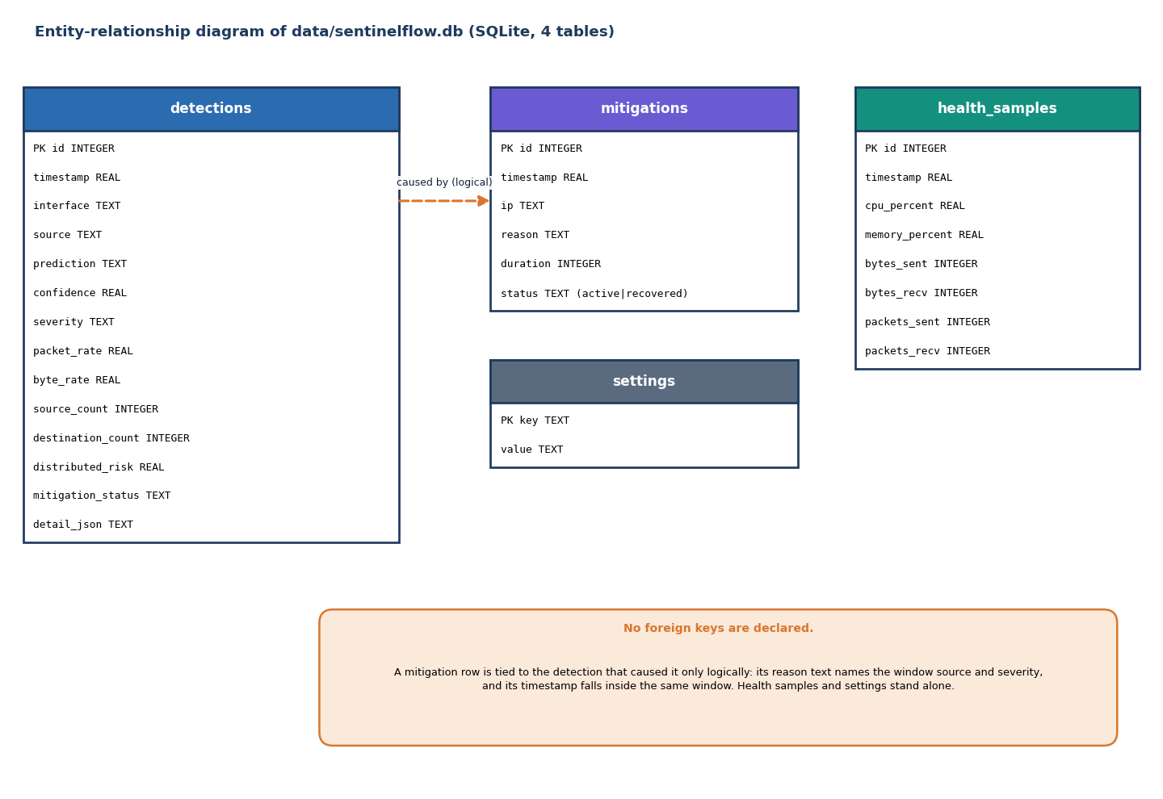
Figure 9: Entity-relationship diagram of the SQLite database: four tables and no declared foreign keys.
database/db.py creates four tables. detections stores one row per scored window with its prediction, confidence, severity, rates, source and destination counts, distributed risk, mitigation status and a JSON blob of the full detail; mitigations stores one row per quarantine with the address, the reason, the duration and a status of active or recovered; health_samples stores the psutil counters; settings is a key-value table that the code can read and write but the API does not currently use. No foreign keys are declared: a quarantine is tied to the window that caused it only by its reason text and its timestamp.

Flowchart of the core algorithm
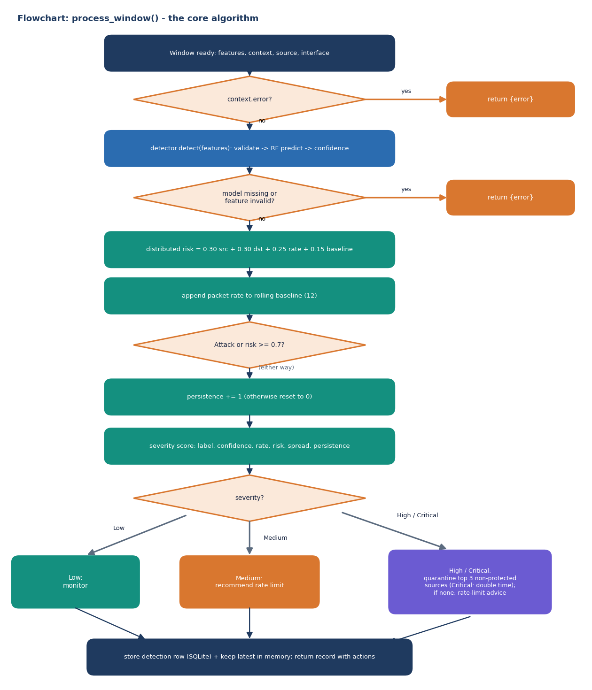
Figure 10: Flowchart of process_window(), the algorithm every window passes through.
process_window() first returns an error record when the capture engine reported a failure or when the model is missing or the features are invalid. Otherwise it computes the distributed-risk score against the rolling baseline, appends the packet rate to the baseline, updates the persistence counter (one more consecutive suspicious window when the forest says Attack or the risk is at least 0.7, otherwise zero), computes the severity score and branches on the resulting level: Low is monitored, Medium produces a rate-limit recommendation, and High or Critical quarantines the three most active sources that are not protected addresses (twice as long for Critical). The detection is then stored and returned.

